ID MIER ANTSALG

In maung weidsa buit Mund Weir Dwo un continuation ios 1914-1918 weirs. I Deutschi, duct ab ir dictator Adolf Hitler, eent gwaukan de schiawkiene id scham irs marloubia face i Allieits. Deutschland reoccupit Rhenland in 1936 ; in 1938 id annex Osterreich ; ed unte dwo etapes in 1938 ed 1939 id occupit amalan hol Chekhoslovakia. Apart proteste verbal-ye, neid land pit oistope id. Dind, dien 1sto September 1939, Deutschland invas Polska. Dwo diens serter, Grand Britain ed France videclareer weir.

Polska fiell, ed unte ia six sehkwnda munts quant buit baygh sakwn, tant quem leuds bikiel to id Stragno Weir. Bet in Aprile 1940, id hammer retus. Danmark buit lambhen alnos per surprise, Norge capitulit in Jun.

Dien 10 Mai, Deutschland vols westtro ; lahsit Nederland unte quar diens, ed Belgia unte tri hevds. Hatta France fiell unte just sept hevds. Id Britisch Expeditionar Force em 250 000 yeudmen kwohr un bolt combatretraite in Dunekyrk, kay bihe kjiugnanto destull desconcertant-ye ab un armada smulken nauks.

Britain taiper stahsit saul, samt id tehrg uns fauric deutsch invasion vyeigend uper sien cap. Quanto eet ad Deutschlando zaruri kwehre eet destruge id Royal Air Force...

Alistair Thompson eet Pleuklieutenant in id Royal Air Force in September 1940.

Is hieb literal-ye gwiwt in Biggin Hill aerodrom unte ia dwo akhir munts, dayim pristahnd. Ielgs kun id sirene hul, minst-ye tris cadadien, is eeklaupt do id cockpit siens plav.

Id Luftwaffe, pleukeihnd pleist-ye Messerschmidts (Me109s) ed Dorniers, hieb criscen sien attaques ed, speit gwaur leusa, tadrijan upertrehsit eyso squadron.

Dar quar munts prever, is eet un novgwehmer in tod squadron ; unte ia akhir pauk prev munts is hieb viden maungens gohd pilotes nehce horrible-ye. Taiper, isge eet un expert bayna iens novgwehmers.

Ielgs kun is bipluk, is mohn esiet sien sensto mission. Tod kwecto aunfin rund om nasuk swehpen, oku chifan, diesel dums ed id bodereihnd baub iom canons ed Merlin motors tadrijan upertrehr iom.

Sem posmiddien, unte un bragv speit in id chaos, eys ment rafliet kye sien hem ed familia. Id sollit esusevacuet ex London taiper ; ye id senst ker kun is hieb viden sien kerabs, eent sa-fortrehcend. Warwn hehlptu quelgvonc dar in id nagor. Is hieb intercepto douzens attaquen, bet plus douzens hieb ghohden neempedisen mukes ir bombes ep id citad.

« Peind, peind... peind, peind » mugihsit id vocbehr.

Automatic-ye, Alistair stieusit ub, endund sien trakh menxu is oisprintit do sien intizarnd Spitfire in rudho pterg. Pos minutesis buit in id air, pleukend uper ia glend polds os Sud England, po khitergwohmen visitors...
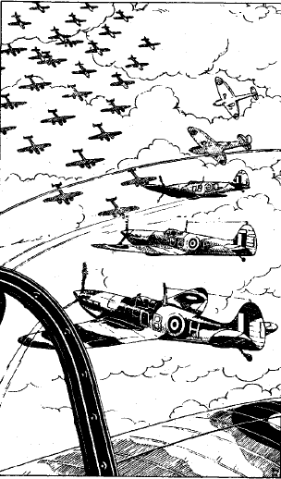
« Hello, Red Leader. Control her. Bandits tehrnt caust uper Dover. Vector 62. »

« Roger. Red Leader kalt Squadron Six-dwo. Glehmte do 20 000. V formation. Gweupte id R/T leur, plais, Swamens. »

« Yellow Leader kalt Red Leader. Bandits ye 2 saat ender ».

« Red Leader her, message pretet. Control – meis quem cent bandits, dwidel Dorniers, dwidel Messerschmidts, six mayls dalger, trehcend nord-nord-westtro. Attaquems nun. »

« Red Leader ad squadron. Formation attaquet. Cheuste vies tarjas, Swamens. »

Ant ed ender eet un strohm deutschen plavs. Uno mono Messerschmidt 109 swohbh graciu-ye pri Alistairs plav ye uper 350 mayls pro hor. So khiek navaxe id. Bet, dalger, is ghohd gvehne un Dornier.
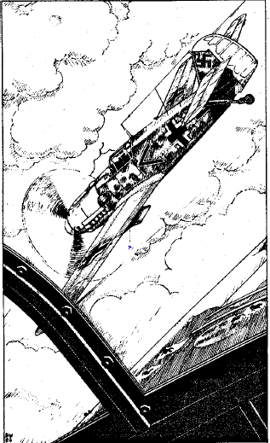
Ies Deutschi vigwirliey. Pleist bombers hieb muct ir onos do id mar. Ne heihient London ye tod ker, mohn Alistair.

« Red Leader her. Suakwohrt, Swamens. Smad escorte ia hem. »

« Roger. » iey is do sien R/T.

Ies oiskehdus peinds abpluk eustworts. Alistair na-sohkwit ia. Hatta aun ir onos, ia deutsch bombers eent meg lenter quem ia britisch plavs ed abvic bachimien peitend-ye abdehe ta ud se. Parachutes nukteer id waurn maung nieutes abandoneer ir airnavs ed iskw id comparative salvtat ios Armelchenal. Alistair eet taiper ye midvia kyid Franceois caust, ye quasi 400 mayls pro hor.

« Red Leader, Red Leader, nov formation om bandits gwehmt kye nos. Circa penkgim, quant wighplavs ! » mohld id R/T.

« Red Leader her. Gehlb ed glend ptergs natrehpte vies tarjas. Rudh ed blou sehkwte me do 20 000. »

Kun Alistair taat-ye naglohm, is vis uno Me109 steurdend ex ia nebhs seid kyom. Ed id canon tos deutsch plav hihsit id motor ios Spitfire. Teug naft ed glycol covehr eys windschib ed flammen zabaans lud menacend-ye kyid cockpit. Alistair hieb neid alyo cheus quem abandone sien plav ed slah retro id canopeia.

Kun is glohmber ex id cockpit siens brandend Spitfire, id stayg airblast bich iom apo id airnav.

Alistair contit ia secundes, dind protietraxit id spartak siens parachute. Id naft ex id brand hieb covohrt eys glegules ed is oislah ia ub ep sien chol pos id parachute hieb ghyaht. Is dar ghnih sien okwi kun is niek id wed.

Id Armelchenal eet sakwn ed ne pior srig. Is disdwerwit sien parachute ed abkielc sien gwaur pleukbauts. Se leurus ud ia viels os sien parachute, is kwahsit oidihes sien cauchuk dinghy ed, exhausen, glohmber do id.

Alistair intizier in id dinghy unte kwecto hors. Id waurn eet taiper tuich ed quantum is ghohd eent i mevs oiskreitend uper iom. Xep gwohm ed is se preparit uni baygh incomfortable noct in id Armelchenal.

Kun buit noct, is ieur id swon unios motor – ne un plav, sontern uno nav ! Alistair slur sieno naudhbleigos ed yis un rudh rakete arche do id waurn, dind is resess ghom.
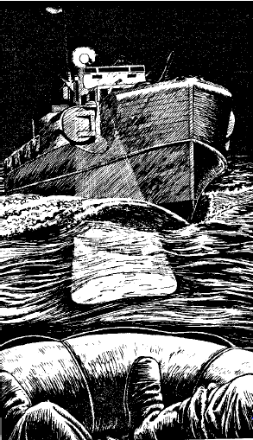
Ex id temos, un forme wierdh. Eet un patrolnav. Bet kun id gwohm proscher samt sien paurskluces reperend iom, Alistair vis dekhschat-ye id eet deutsch, ne britisch !

Is neti ghohd kwehre ject, sonst bihe un bardach. Kun id kjiugnansnav gwohm claus eys dinghy, Alistair visit sien peindo ye id prest kero prokwtos. Oin Deutsch ghesorit id gwaur machinebunduk ye id heck ios nav, trehpend id kyom ; tri alyi eent parat ad hisse Alistair abord.

Is bulandst iom tri, okwivid-ye un officier, sieyg « RAF kaput ! » ed Alistair samstohmit neukend-ye. Pro tom, id weir eet, bariem taiper, khatem. Hohlpen ab iens Deutschens, Alistair glohm abord ed toy ei dehr un blanquet ed un deumend mugh os cofie. Is installit-se do id relative wierme ios frontkayut ed niercit quasi fauran.

Alistair gohr kun id nav bendrit do id liman os Calais. Ia schrams ios isgur katu po tod urb tik oik munts prever eent dar evident. Ia docks eent strahn ab pwolsubmers navs, blockend ia channels ed oistambhend ibs Deutschims id pleno neud ios liman.
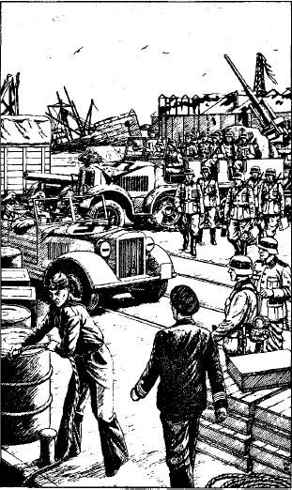
Ia quies eent oposchepran. Dockorbaters eent besic med sklade onos menxu Deutschi soldats stahr wakht in impassible rangs ed menxu schtabautos bieub ub ed ghom id wedorfront.

Taiper, id nieute lohnc amars do id ouper ed mox fundier id nav. Scattules om munitionen ed gudangs stahr bachimien. Yadi un bombern squadron habiet ghohdt attaque her !

Is capitan znieyc ad Alistair stahe ub ed, reticent-ye, so skiend ex id nav sekwos iom. Con alyo naut, bo trohceer kyid menegh.

Pos oik minutes ghang, arriveer do id chefquarter ios kjiugnanunitat, ed Alistair buit entrihn id bureau ios commander kay bihe interrogen. Un kalv, corpulent wir os nedefiniht grade sess claus un scribtable, part-ye kohlen ab khartasmagurs. Kun Alistair prohp, is wir sess ub.

- Ah, RAF ?
- Ya, jawieb Alistair, mustahkam.
- Vies nam, grade ed adadh ?
- 67524 Flight Officer Alistair Thompson, swamen !
- Yu buat vis strehlend kyun deutsch pilote qui hieb skans ex sien airnav, Flight Officer. Quod habte yu ad nabahe ?

Alistair narrit sien exploits uper id Armelchenal ed ye id fin os eys bayans, is Deutsch kwohk satisfacen ab eys explications.

- Som masrour yu habte chust coopere, Thompson. Neti tehrbo enwoghle vos eti. Yu vahte bihe abnih do oin quartier ios Luftwaffe massoul de nistrohlen RAF pilotes. Khuda hafiz.

Un Kubelwagen schtabauto eet parct exo samt tri armet yeudmens in id, ed Alistair buit jaldi abwohghto kye tod Luftwaffe quartier.

Id urb eet pleno med soldats. Ies Deutschi kwohk suavance in ira preparations pro ir invasion os England. Alistair viensch dar esus in id hava defendend sien vatan protie iens ed is balstohm se ob id rhalt quod hiebit brighen iom hetro.

Taiper, is arrivit do id Luftwaffe quartier ed buit cellbohnden pro id noct. Ye prue, un guarde arrivit samt un bol piut ed uno mugh os cofie, bet is ne bahsit Englisch.

Hors serter, Alistair buit ducen do id caudghehrd ios Chefquartier, tuich ploisko un onwogh samt ids kwehlend motor ed dwo deutschens soldats oistahnd nastraj ye id caud ios vehicule. Ghangus clauser, is vis id onwogh pwolpohld med Britisch askaris, quantens skehptend bihe wohghtens do id bardachenlagher. Alistair glohm abord ed se presentit. Sept alters kwecto hieb esen vanen unte ia aus aghyernhors ex local prisons.

Penk iom prisonern eent ies survivers uns Blenheim nieute – Flight Lieutenant Livermore, Flight Sergeant Johnson ed ir pleuknieute, McDonald, Robinson ed Common. Dwo alters eent wighpilotes kam is : Parkinson ed Cowie.

Id onwogh tohrb diu pre ses parat ad abwehghe. Tri Deutschi sess in id cabin ios front ed dwo alters joineer iens Britisch in id caud. Bo soldats eent yun ed nerveus – oiter hieb uno machinebunduk, alter un bunduk. Tadbir-ye, Alistair chohx tens bo, dind aunbren sien driugs. Eet kwecto seller skehpte ses ruri pre pites quodgvonc.

Id onwogh sohkw id strad kye Lille. Ye cada mayl waurs deutscho schowbeyo kyid caust. Dind, id onwogh stopit ep id stradtaluss in uno smulk bosc ed bo guardes exskiend pre znayce vasyims Britisch sehkwe iens ed oistrehce ir jambs. Alistair abghieng lent-ye, pretendend-ye trehfskwe un privat loco kay sgwenes uno natural naudh. Kun is trohc, Alistair kieusit is prokwst guarde apterspohc iom suspeceus-ye, bet so kwohr neid kay stope iom. Nakus sem buska, Alistair decis abcurre.

Glanzend ye un senst ker apter se, Alistair bidrahsit. Nassib-ye, eet un ravine just trans ia buska do quod is ghohd skande. Sprintend unte ids bund, is visohnd-se tiel un taluss ye circa dwocent yards dalger. Ne eet swon os persehkwen apter iom. Ambhspehcend jaldi, is pit kehnse id gohdst abitner. Id bosc eet denser her, quayque eet un aykwos os leudend bare grundo dexter quem is.

Alistair nastohmb unte id enderbosc hin is ieur un uradel cracke levter quem is just pre un wehlend voc sieyg : Hände hoch !

Hatta basic Deutscho sis iom prete « hands hog », ed aun cheus, is sohkwit tod wehlen. Un pletwosto deutscho sergeant emers ex un tegut samt uno machinebunduk is tohrpit preter kye Alistair dind tsay do id direction quetos so gwohm, ed ghabih iom is dohlg rikes id onwogh. Aundwoi is tuntos aptersehkwiet Alistair prokwtos.

Kun is reemers ex id enderbosc, is vis od tri eysen driugs ne hieb esto tem norocti quem is. Hatta taiper, ies Deutsch eent sehlkend ir nayvs do ia buska.

Oin Deutsch kwohk mulayim-ye vurnt ed quanti eent baygh-ye grasban kun ies churd Alistair ed eys survivend sokwis do id onwogh.

Ye id niebst etape ye un local karcer, is prighens plus dwo prisoners ed diehr med hathkalis vasyens gospotis ibs dreun lattes iom sedds ios onwogh. Vahr kwecto tehre Eust France ed shayad-ye Deutschland poskwo.
Id reste ios safer buit large-ye aunwakya. Viarriveer ye oin fayront ad Stalag Luft 14, prokwem Wiesbaden in Deutschland. Ies soldats ios onwogh prodahr Alistair ed eys sokwis ibs lagherguardes pre abwehghe.

Id lagher kwohk suapact. Kun Alistair passit unte id presto dwor is vis id eet epkihn ab un bulando tor samt uno machinebunduk wals atopp. Oins eni, stahsit in un ghohrdt parade area quod is gnohiet moxu ka id Vorlager. Spehcend trans id brozdhos is ghohd vide un large grupp om prisoners sammelt pre un serie baracken eni id gordos kay sellgwehme iom.

Alistairs gruppo buit entrihn un levter trev quod kwecto dieugh bo ka un reception centre ed un guardencaserne. Eins po eins, ies sept ios grupp buir obsoct, dind ibs buir dahn dwo blanquets, toualette schowbey, un ghabel, un gamelle ed un smulk gep tabak.

Ghangend con Livermore ed Johnson, Alistair entrit id magno gordos ed quanti buir saluten ab id reste iom bardachen. Fauran, un strohm questionen ibs buir smitten.

- Ne hant ies Deutsch landen do England, ne ?
- Quer buat yu nistrohlen ?
- Kam leit id in London ?

Med un serie neuken ed monosyllaben antwohrdeer tibs questions aun zaghange perodh kay ghate iom Senior Britisch Officier.

Id barack os Group Captain Evans oistahsit medsu id Britisch part ios lagher ed Alistair ed eysi sokwis buir ducen in ab un grupp alyen prisonern. Sleivend sien uniform, Alistair stus eys dwer.
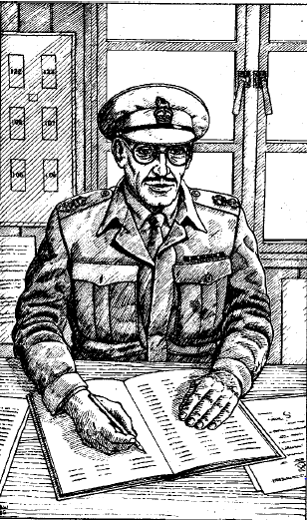
Is S.B.O. eet un destull buland medioquargimtiat wir samt un bril ed un vagh-ye aristocratic wajkho. Is sellgwohm Alistair warm-ye ed prohg iom ke sess. Eys quartier eet destull comfortable bet lyt angh. Med uno mliak voc is oisprohg Alistair de eys nams, grade ed adadh, ed niscripsit ia do un register ep sien table. Is assignit Alistair ad Barack 113, ye id sudeust wangwl ios gordos ed suggestit ei swehpe pos eyso safer.

Alistair restahsit ub, salutit iom ed likwit.

Eys barack stahsit ep bricken galgon, circa dwo peds uper id grund. Un hakime precaution, mohn Alistair, quod difficilih tunnel direc-ye ender id barack aun bihe kaut. Trehtus ub ia stieupens dind entrevs id long dreun treb, is vis eet concepen kay bewikes dwogim prisoners. Kehnsend grosso modo yeji id numer baracken, is hissieb ter solleer ses circa tricent prisoners in id lagher in summ.
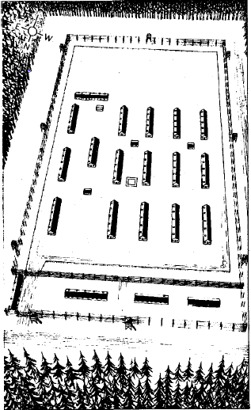
Plur RAF yeudmi lyohg leisend ep iro crovats ; kwecto ne eet druve-ye alyo kwehrtu. Flight Officer Read se presentit ad Alistair ed ei explicit od maungs tom wirs eent her pon 1939 au in-kap 1940, capturet pos landeihvs ir plavs do France au ia Niterlands. Idwert lagher enderbrigh semschi Franceois, Nederlands ed Belg airyeudmens kapen unte id invasion iren lands.

Alistair bikhiss strak, ed pos balbelvs unte un khvil de ia weirwakyas, is abnuk do un deub swehpen.

Un frid protiebud iom. Is officier ios couchette nieb eysum ei explicit eet id « Appell » - cadadien parade ed capenconto. Kun Alistair troht do id meithel ye id caud ios lagher, is math od tod eewakyet cadadien ye 8.30 aghyern ed 4.00 posmiddien saat. Apart id Appell ed id ritual os barackbehnde iens baradachens ye 6.30 saat cadavesper, ies Deutsch kwecto eelinkwnt iens prisoners irims wi besoyns.

Arriven ep id meithel, Alistair vis rangs airyeudmen, ardehn per nationalitat, samt ir superior officiers front-ye. Pleisti kwohkeer skeud ed schawngdanus – payn surprindant chunke eent her tem diutos.

Id capenconto eet lent, iens « Goons » (prison personnel) currend hetos tetro engwn ia bardachenrangs. Poskwo vasyi prisoners buir slehmberiht ed abrusch kay quues pro snidan. To eet id presto druv waurmen pro Alistair kay ghate id reste om sien Britisch samlandans.

- Quayts hant kamyapt antsalge hetos ? Sprohg Alistair un airyeudmo nieb iom claus id meja.
- Ne maungs. Six, credeihm. Ies Franceois semper peite, bet pleisti ex iens rebihnt kapt. Yed sont gohd tunnelars, jawieb is wir.
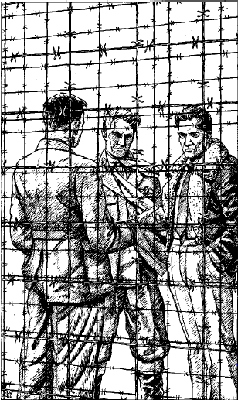
Poskwo, Alistair spasserit engwn ia baracks, ed vis un grupp om franceois bardachens weulkwnd ant sem treb. Tengier destull suspeceus. Alistair mohn od eent planend semject, maghses un antsalg. Poskwo, is wiender tsay kye sien part ios lagher, ed passit id reste ios dien leisend. Pos id Appell, is khiss destull strak, nespekent is hieb kwohrn quasi neid hoyd, ed is lyohgit ghom aus.
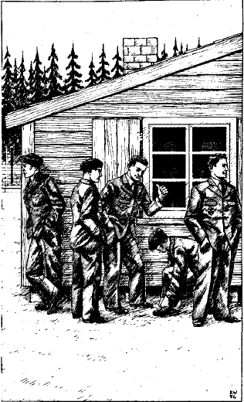
Circum 3.00 saat maurg, id mugeihsa om sirenenfrid protiebud iom. Unte uno moment, is quasi se credih tsay in London, kleund un air-raid warnen. Is bipaniquit, mehmend od id lagher hieb nia air-raid schalascha.

« Semquis peit antsalge, » commentit is wir ep id niebsto couchette samt excitation kun is glohmber ghom. Alistair kwohk id sam ed gwahsit scrute per oino iom fensters. Is vis un wir in civil vesters currend pri eys barack. Agend instinct-ye, Alistair ghyien id fenster ed znieyc ei entre urgent-ye. Is ambhspohc frenetic-ye pre vire kyom Britisch ed skande cap-perodh unte id fenster.

So wir eet Belg ed vohs un baygh-ye gohd imitation os civil costume. Is bahsit pau Englisch, bet eet okwivid-ye schakir de Alistairs hehlp. So kamiebit preter od eys antsalg hieb duswohrten quan is incontrit un patrol samt warder oik baracks dalger. Is paniquit ed abcurs, bet ne mohn od quiskwe hieb viden iom pre un paurskflottluce kiep iom do sien bam unte un secunde. Is kamieb abklaupe ed eet edvas yakin od ies Deutsch ne hieb vis iom entre Alistairs barack unte id fenster.
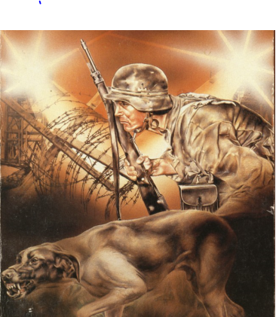
Posdini, so visitor kwahsit endermerge bayna iens Britisch kun ies likweer pro id Appell dind joine sien samlandans aun bihe repern. Serter unte id aghyern is reprohp ed, samt uno mier smeih, duxit Alistair ad ghate id Antsalgscomitee ios lagher. Ies kwohk dohbro impressen ab eys okubren os pernocti ed bohd coopte iom do id comitee.

Alistair chus wehrge in id brozdhosxeimen. Idso specialist eet un Belg, Auguste Dechant, qui eet in id lagher pon circa tri munts, bet qui entrim hieb esen massoul pro quasi id dwidel iom « gwirlays » - kamyaben antsalgs -ex id camp.

Eys Englisch eet neigvos ed eyso swoin et multinational. Is ambhriss ad Alistair sien actual project ed ei propos un place eni.

Ids plan eet sege id viel unte id noct pre id tentative, dind meremettise id med sigwring, it ghehdiet id antsalgpeiten bihe tyicen jaldi.

Alistair ieur od tod tentative tyehciet mox, ed wohlp smyehre id, ed convic id Antsalgscomitee ke bihe inclus do id grupp. Esient six, pati Alistair. Id reste ios swoin consistiet dwo Franceois, oino Nederlander, oin Belg ed alyo Britisch. Id plan dehlgiet inkape kun ies guardes habient dejourt pon un pair horen ed esient minter elangver.

Alyo Britisch, Reggie Butler, un ex-Hurricane pilote, buit chust ka chef. Is decis id tentative tyehciet unte tri diens ed od yant exter id brozdhos, vasyi viaghabelient kay difficilerihes id task iom Deutschen quoy kapskwient iens.

Ye id sayct saat, ies six ablat kyid brozdhos ed localiseer id torm. Pos kanaateihvs id sigwringviel ex ia stets quer id brozdhos hieb esen segen, ies oisnohg unte id ein pos ein. Dind, kun dwoter Franceois stohmb unte id torm, is oisluber ed tyic un blosk fallend-ye. Noroc-ye, ies Deutschi kwecto ne ieur id.
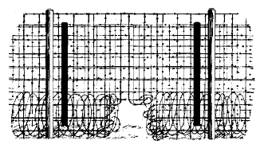
Poskwo, jaldi, ies tohr id breyel inter id lagher ed id forest. Arriven sub id steg iom drus, ies vienscheer oku sell nassib ad mutu, ed moniesc. Alistair decis trehce nordwesttro, kye maghses Belgia.

Id forest eet baygh deusk, pauk luce penetrend id tavan ozden ed waraken uper iom. Id gwahsa eet gaddar ; fallen ozda strahr id grund ed id enderbosc eet dens. Pos oin pwolhor is viniek id kenar ios forest.

Westi is ghohd vide ia luces uns village. Kun Alistair niek ia presta doms tos weik, auror hieb zaausct. Is khiss pior vidil, ghangend mon in sien RAF uniform. Teupend apter uno mur is oisduit sien jaquet ed sien cravat ed plohc ia do welutro, spehndo mae anghen kauiet id distinctive blou sienen bruks. Resolven tod probleme, eyso stomak se mehmih. Alistair eet heunghernd ed hieb neid alyo cheus quer entre un cafee just medsu id village.

Is sess claus id meja dalgst ud id dwer ed tup apter id menue. Un veut couple mejend snidan spohc iom dind volseer tsay kyir chifan. Poskwo un kellner prohp ed Alistair stier aunidee ad id menue ant se. Vicheusus sien chifan, is Britisch kamyieb kulkes sien accent hanjowend sien chifan. Is kellner rik penkwe minutes serter samt un taler vursten, dvan ed cofie ed ei vienscit sell apetitt.

Alistair guriegh id eddmen. Eet id leckerst id eememejit diutos, pos hevds om naps ed ersatz cofie, tod mergist liquid i Deutschi pohr instet druv cofie.

Bad ye tod moment vighieb is od is hieb neid kay payghe. Tun is oistahsit ub kay linkwes, nin-ye ambhglanzend. Id veut couple neti eet ter ed is eet saul in id cafee. Alistair lent-ye trohcit kyid dwer. Stayg is kellner prohpyit ed ei mlusit in Englisch : Wait, please.

Staunend, Alistair stopit ed spohc iom ghange prosch iom. So wir entrih iom id cucin ed seddih iom.

- Quosmed ghehdte yu me salgihes Deutschland ? Sprohg Alistair.
- Wehgho do Lothringia cada hevd kay kaupe meriendes pro mien dukan, jawieb is wir. Ghehdo kehle vos honoct, ed cras comwehghsiemos do Metz. Tun vos ducsiem uni wir io gnohm. Kad is ghehdt koimrikihes vos. Mien nam est Georges Luboff. Som Deutsch per gnahsa, bet Franceois per kerd. Mien bo parents eent franceois ed her eet ir dukan. Ho repris id quando mien pater mohr tri yars prever. Mien mater hieb ja mohrt. I Deutsch kame mien cuisine, ed me suagnohnt, me treusent, confidit is.

Georges duxit Alistair do id granar, quer wohs un crovat. Is Britisch dienk iom ed so ei recommandit swehpe, ob fortrehcient aus posdini.

Georges protiebud Alistair ye 5.00 saat aghyern, bringhend con se un hol om civil povestis. Is urs iom Britisch ad endue ia jaldi dind ad gwehme ghomdrabs kay edde semject. Alistair guriegh un fayno snidan dind oistigh do id onwogh.

- Mien plan, biexplicit Georges, est pretende ste swehpend ed nudes id identitatscarte miens brater. Ies guardes gnohnt iom ed sigwra nient iskwes werds.
- Quer est vies brater ? Sprohg Alistair.
- Semquer in Norddeutschland, jawieb is. Ne vidmos mutu semper kay jusaye id dukan, Henri ed me, ob is meilt id hamrahsa alyios franceois familia quod hat un restaurant in Hamburg.

Georges balbiel aunstop untitner ; speit id fact od is credih hol sualeitiet, eet okwivid-ye nerveus. Is explicit ei ne eet difficil obtene transit permission ud iom local commandant isghi mejit ops in Henris restaurant.

Eent baygh-ye pauk Deutschi soldats visible ep ia strads, kun ies niek Birkenfeld, circa trigim mayls piern ud id prever grance, ies dyohrc un viastamebh seid perodh.
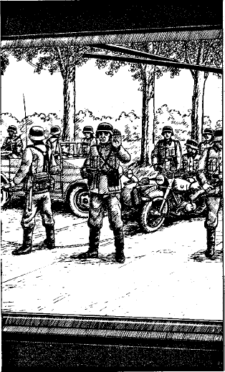
Ies Deutsch recognihr id onwogho kun tod gwohm prosch. Georges exstigh ed ghiengit kyens soldats. Ex id pau quod Alistair ghohd aure ed prete, Georges sieyg ibs is hieb viso sem wiro drahe poldskeir circa dec mayls retro, trehcend kye Luxembourg. Ies dienk iom ed mohldeer to per radio ei chefquartier. Georges ibs viensch khuda hafiz, rik id onwogh ed restars id motor. Ies deutsch lur id perigumt pro iom. Ne hatta bud ies iom ke dik sien papiers !

- Sont paurskend un antsalgus bardach, bet ne hams viden sem, ne, Brater ? Glihsit is. Ho saygen ibs ho vis semquom curre poldskeir ; me hant crediht.

Kheissend meis relaxen, taiper kun is wois is ghohd truses Georges, Alistair nierc.

Abrupt-ye gohr is kun Georges oistopit id onwogh ed sgwes id motor.

- Quer smos wey ? Sprohg Alistair.
- In Lothringia, jawieb is, nabahnd samt uno smeih. Her dehlgo te linkwes, brater. Tehr id strad tiel id witer dom ed sprehg pro Poti Pascal ; sayg ei te ho yist, ed od es ex id RAF. Siet koimrikihes te kamgvonc.
- Mersie, Georges, iey Alistair mussafahend-ye. War pro te ; spehm siemos reghate mutu quan id weir sessiet khatem.

Is nuk ed motionit ei ke spohd. Alistair gwahsit oistundes id dwer tos witer dom. Uno mediat wir ghyien ed is Britisch ei repetih quo Georges hieb ei baht. Samt un beghspace wajkho, is entrihsit Alistair. Glanzend ye id senst ker apter se, is vis od eys sokwi hieb ja likwn.
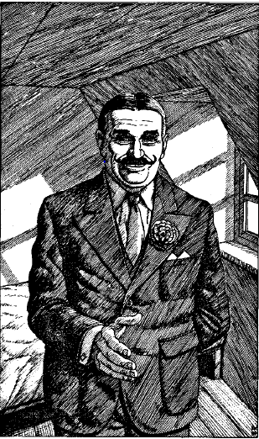
- Sellgumt. Mien nam est Pierre Blanchard. Aygwo plur florenmagasins in tod region. Hams hab' plur successa nuper kay antsalgihes bardachens tsay do England. Baym yed, od ies Deutsch nos apterighnuent. Est pior dangereus pro vos mane her. Vahm vos yises do mien prient in Arras, tetos yu sessiete payn meis quem cent kilometers dalg ud id caust, iey is ei.
- Mersie, jawieb Alistair. Preihm ia megil risks yu emte kwehrnd-ye to. Quando siems wey linkwes ?
- Pos oin hor, smad spehe. Un train fortrehcsiet kye Paris ye 4.30 saat. Tetos yu dehlgsiete change ed stighes do id train kye Arras.
- Vahm io gwahe mon ? Jawieb Alistair med un beswurghen voc.
- Non, mon ami, iey is. Mien dugter Madeleine siet hamrahe vos ; ia hat ja escortet evadeits prever.

Pierre pors un stul ad Alistair qui skohpt iom kwehrnd ia oik senst arrangements. Oin pwolhor serter, un gwenak, ne meis quem dwogimat, joinit iom Britisch do id kyal. Ia vohs un akstercolor rogv ed dohrj un trencho sub sien brakh.

- En pro vos, M'sieur. Way ne hams maung alyum ad schehnke vos, ieyit ia. Nun dehlgmos linkwes, mien pater vaht wehghe nos do id station.

Bo joineer Pierre do eys Renault oncarr quod duxit i do id centre ios urb.

Kun Alistair vahsit exstighes, Pierre ei schohnk un pistol. Is Britisch preter spohc id desconcertet-ye, bet Pierre nuk rassurant-ye. Alistair ghens id, dienk iom ed exstigh. Madeleine urs iom ad spehde ed bo comghieng do id station.

- Mante prokwem me quando ghendsiem ia tiquets, ieyit ia ei.

Alistair nastahsit taat-ye prokwem iam. Pos oik minutes, ia ghens ia tiquets ed bo comghiengeer kyid perron.

Id train eet quasi desert, pauk leuds pohnd hakime gwahe France unte un tem khak zaman. I comghieng pri oik wagons pre vistighes in.

Pos i hieb sedden ghom, Alistair ne relaxit pre is ieur id swistelmehld ios station chef ed kun id train vistars.

Alistair clusit sien okwi, linkwndo Madeleine wiekh uper iom. Taiper, is ieur ia muzlim murmures uns conversation, yed na-simulit swehpe.

- Alors, fous allez à Baris ? Sprohg un voc samt un akster Deutsch accent.
- Oui, jawieb Madeleine, avec mon frère Emile.
- Ah, fotre frère... Alors il ne ferra bas te mal si che fous infite au dhéâtre turant cette fin de semaine ? Fous safez, nous les officiers allemands nous afons douchours les meilleures blaces bour les meilleurs spectacles, nabahsit is.
- C'est-à-dire... Je ne suis pas sûr que mon mari apprécierait... protiemlu ia.
- Et où est tonc fotre mari ? Sprohg is Deutsch.
- Normalement il devrait nous attendre à la Gare de l'Est, iey Madeleine desperat-ye.
- Che le gombrends ! Gar fous êtes drès cholie ! Jawieb is Deutsch.

Tun, Alistair simulit gehre ed sprohg :

- Madeleine, où sommes-nous ? Déjà à Paris ?
- Bientôt, Emile !
- Très bien. Bonjour Monsieur, iey Alistair ei Deutsch.
- Monsieur est un officier allemand, Emile. Il souhaiterait m'inviter au théâtre durant cette fin de semaine, jawieb Madeleine.

Is Deutscho smihsit ed nuk.

- Mais que va dire ton mari ? Lui qui travaille pour le gouverneur militaire allemand... lugh Alistair.

Id lige ios Deutsch erudh. Is okwivid-ye lyt swurgh taiper... ed vilikwit. Pos un pair horen, id train viarrivit do Paris.
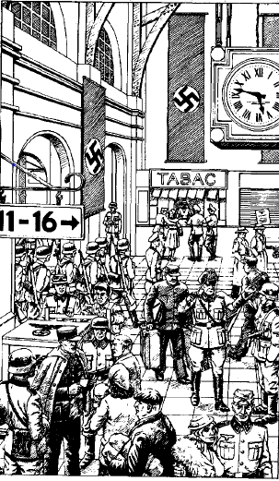
Ia vocbehrs mugihr deutsch martial music, intersegen ab amalan inpretable trainmehldens. Nassib-ye, Madeleine siegv unte quer gwahe, preter med id metro, poskwo do id Gare du Nord.

Id train ja skohpt engwn id perron. Bo Alistair ed Madeleine stigh do un lytil wagon samt tik dwo roigs om sedds. Eet nimen alyis. Pos oik minutes, id train stiert.

- To tehrpsiet dwo hors au lyt meis, iey Madeleine. Ma ne swehpies tu ?
- No, tu swehp. Remansiem probuden unte un khvil, antwohrd Alistair.

Ia ne arguit, ed mox oisnud enpace. Alistair ne hieb edden destull diutos ed is oisnig sien hand do sieno mantelgepo spehnd-ye trehve sem piut. Yaghi, Pierre hieb dehn un appel ed sem caise do un sachet.

Kun is inkiep sien dapan, is aunstohg un brev samt sieno nam ep id. Tehrus id vulbh is lis :

Kyar Alistair,

dat ne ho haben id waurmen os person-ye sprehge vos, way vahm dehlge kwehre to med tod brev, quo vos linkwsiet pau cheus.

Baym an mien dugter, Madeleine, sessiet in danger sei mansiet con me. Kam vos ho saygen, i Deutsch me apterighnuent. Sei me arrestent, est pau chance an Madeleine skapsiet ir vengence.

Plais peitte dughes iam salv do England. Ste mien saul speh. Kad yu aysiete iam un behrmen, bet vos sigwro ia baygh sua-sagvt tekhnasse.

Io ouzer ob kwehre to vos, bet ne ho alyo cheus. Kad yu habiete kwohrt id sam in mien position.

Mersie ed sell nassib,

Pierre Blanchard.

Alistair diu stier ad id brev pre rebughes ed kulkes id.Is decis kwehre kam Pierre hieb iltijet iom, bet mohn esiet seller mae sayge ad Madeleine, iaghi tik reicskwiet bi sien pater. Is eet gwaukan de salgihes iam France, quakwe esient ia problemes tod decision bringhiet. Kun id train bientrit Arras, is gentile-ye protiebud iam.

Ghendend Madeleine per id brakh, Alistair stigh ex id wagon. Quayque id traino ne eet plen, eet uno muhim menegh ep id perron. Tadrijan i se sohnd unte id waurgo kyid tiquetcontrol. Ter eent dwo railvia employeits ed tri soldats chehxend i prigwehmend passagers.
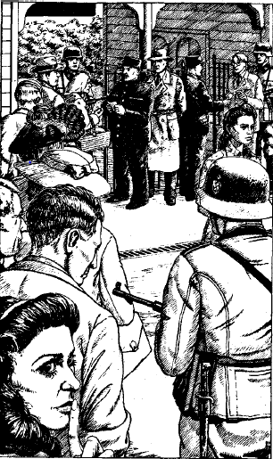
Madeleine ed Alistair prighieng prosch tens, salgeihnd ir tiquets ed fals identitatscartes. Kun i pors ia ad uter railvia kwehrant, un sixt wir, vehsend civil povestis, prohp ed ghens ta ex iom.

- Quod gwehmte yu ad kwehre her in Arras ? sprohg is.
- Gwahsiemos Calais kay vide nies oncle. Upernoctsiemos her hoyd, jawieb Alistair.
- Vido, M'sieur. Vies papiers sont in aurdhen, bet yu tehrpte trehve mox un hotel, ob couvrefeu start ye 7.00 saat vesper.
- Merci, M'sieur.

Exannmend ob rehmen, Madeleine ed Alistair likw id station dind ghieng in id magno strad ios urb. Semject mehnihsit Alistair od hol ne sualit ed, ambhglanzend, is vis dwo wirs ye plur yards za se. Kun i tohr un strad, toy tohr tod strad. Kun i stopeer, toy stopeer. I eent sohkwt. Madeleine ed Alistair vihiebeer paur ed bidrahr do un rineg. Uter wiro strohl waurntro ka warnen, quasi kam desperat, kun i endermers do menegh.

Local weikers ne kiem Deutschens ed itak ti abviceer kay sines Alistair ed Madeleine pricurre, pre rewaurge ep id agmum iren persehkwern. Bo bad miegh zadrahe, ed trohceer kyid addresse irs contact.

So contact, Monsieur Ebonar, sellgwohm ed kohl i do sien granar. Is hieb un cristallreceptor ed sieyg is organisiet Alistairs niebsto trehc do London. Lakin, is khiek tules eme risks, itak nud is sien radio unte bestohmen corta tempsa.

Serter, is hieb sema novs pro iom Britisch :

- Yu sessiete vant ab un Lysander in un pold prokwem Hesdin, ne dalg hetos. Dehlgmos ses prudent, ar i Deutsch woide yu ste in id zone, ed dar vos paurskent. Madeleine, makhboub, dehlcs rikes bi tien pater, neti est sure pro te namane her. M'sieur Thompson, yu gwahsiete id mulakatsloc serter honoct.
- Poittiem io vos tolke unte un moment... mon, sprohg Alistair.
- Weidwos, iey is. Dind, volgend kye Madeleine, is nabahsit : Excuse nos, makhboub.

Madeleine gwahsit ghomdrabs, ed Alistair skohpt hina ia buit exter kleuster.

- Ho promitten aysi pater salgihes iam France, ia dehlcsiet gwehme con me, iey is ad Ebonar.
- Impossible... to ne est possible, iey is darm-ye.

Alistair dik id brev ad Ebonar. Is lis id tadbir-ye ed bihsit vibidt.

- Tamam, admissit is, sessiet seller ke ia linkwt France, ed vahm pliehge ke yu bo gwahte Hesdin.

Quan Alistair revis Madeleine, ia sieyg ei od Ebonar hieb prohct iam ke hamrahiet iom do id mulakatsite. Is Britisch fig surprise ed ay sieyg is ghaws de ne bad habe ad vansche ay khuda hafiz.

Ye id bestohmt saat Ebonar im dahsit ein Sten – un simple bet efficiento machinepistol ops lakapt « smeurpumpe ». Alistair hieb naiwo nudt sem prever, bet Madeleine ei sieyg to eet facil. Id saul ject zaruri ware eet od tod gvond se forstrohl ubtro levtro in action.

Bo glohm do id caud os uno smulk onwogho con tri alyens resistants, Ebonar esend in id frontcabin con iom weghtor, ed abwohgh ex urbo pro un cort itner kye Hesdin.

Quant sualit hin i niek ia oupers ios fluv Canche. Tun, just face i ep id sam strad, i vis un vehicule gwehme kyant i. Id sollit ses deutsch, nimen poittend wehghe legal-ye ye tod noctsaat. Eet quasi neid steg ed ir onwogh khiek abgires barwakt ; schowi dehlgient uperdehle iens occupants ios proschgwehmend wogh.

Alistair ed Madeleine sbei onwogh vihielt ep id stradleizd. Is weghtor ghyien id capot, dehvso sieno « smeurpumpe » extervid ed simulit chehxe id motor. Alters tup bayna ia prokwem dispars buska.

Id deutsch onwogh vigwohm pri ed hielt nieb alter. Ids weghtor exstigh ed Alistair ieur id behngos om pelu peds ob ies « passagers » quens id onwogh transpotit exglohm : un complete ploton deutschen infantiers ! Alistair, Madeleine, ies tri resistants nieb i (Edouard, Maurice, Bertrand), Ebonar ed is weghtor bistrohl ed gvohn vasyens Deutschens ploisko iom hetman qui apokwih med sien pistol protie iom Britisch. Noroc-ye, is lips iom ed buit vihihn ab un Sten firtina tos.
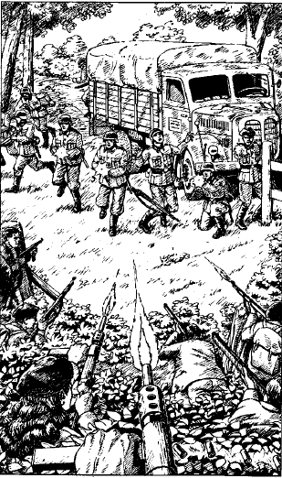
Ies resistants kohl jaldi ia nayvs iom Deutschen do id enderbosc dind quanti kwohryeer ir itner. Id mulakatsite eet un large ouvert pold ye dwo au tri cent yards dalg ud id verdia. Ies resistants diegh smulk mehldogwns, dind emseer defensive positions ambh id improvisen plavdrom per tadbir.

Minutes kwohkeer kam hors hina ies viieur id stump torubow unios motor uper ir caps. Id plav skrit oins, dind biswohbh kay lande. Taiper eet id moment kay sayge ad Madeleine ia dohlgit gwehme con Alistair.
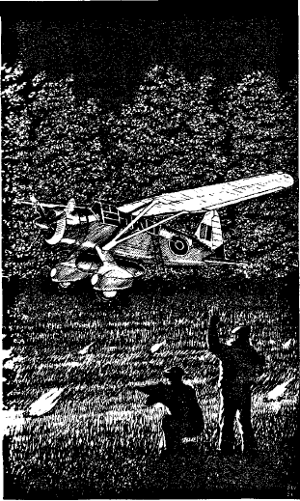
Ia stahsit nieb id onwogh, observend id airnauk descende kyid ghom.

- Madeleine, dehlcs gwehme con me do England. Tien pater me hat promittihn te salgihes France, iam biwohkw Alistair.
- No, som naudhen her. Dehlgo rikes bi mien pater niesghi wehrg her se siseuwt, jawieb ia.

Ebonar joinit i ed hohlp iom Britisch ad convinces iam. Protievol, ia viacceptit. Id plav hieb taiper landen ed is pilote insistit ploukye fauran. I ne miegh wazde meis wakt.

Vanschus adieu ad Ebonar ed altrims, bo Madeleine ed Alistair stigh do id Lysander. Niebst etape esiet England.

Id pleuk buit anter plictic – id nebhcovehr eet ghem buitghi pau chepriene in id air. Pos pwolter hor id liend ep un RAF wighplaven base in id sud. Un wogh intizier Alistair kay wehghe iom do London ed alyo duciet Madeleine do id chefquartier ios Leudher Franceois Armee.

Pos maunga comspens diens, i dohlg sranse mutu. Alistair dahsit ad Madeleine sien hem addresse, ed promittih iam ke scribiet ei.

Vice bihe brighen tsay sien squadron pro debriefing, Alistair buit woghto do un sakwn dom in Hampstead.

Unte id hol agmo, is weghtor eelelohgit ei quo hieb wakyet menxu is eet bardach, ed ne hieb ei explieno ma is bih iom hetro. Samtghi sem staunos oistigh Alistair ex id wogh dind ghieng ub ia stieupens ios dom.

Is buit surpriden ab trehve ter uno Major qui skohpt iom.

- Sellgumt, Thompson, plais entret. Suppono ste anter exhaus' pos ta akhir diens. Aproposs, som Major Dunbar, iey is.
- Dank, Swamen. Somghi destull strak, bet dar curieuser. Ma som io her ? Sprohg Alistair.
- Jackson vaht vos dikes vies kamer kay yu ghehdte mutavehse, poskwo tolcsiemos, tik antwohrd is Major.

Alistair sohkwit iom ordonnance os Dunbar ubdrabs, ed so ei dik un comfortable kamer. Eet un complete RAF uniform ye eys mege lyict ep id crovat.

- Sei yu tehrpte quodlibt, plais just swehnte, Swamen, iey polite-ye Jackson.

Pos se lavus, xeurus ed mutavehsus, Alistair vikhoissyit pwolmensc, ed meis quem lyt intrigen ab iom Major.

Un krigar hamrahsit iom ghomdrabs ed entrih iom id salon. Is Major eet tolkend uni marine capitan. Bo stopeer quando ies vis Alistair, ed Dunbar schohnk un drehnk ei sammel is iom presentit ad Capitan Greenwell.

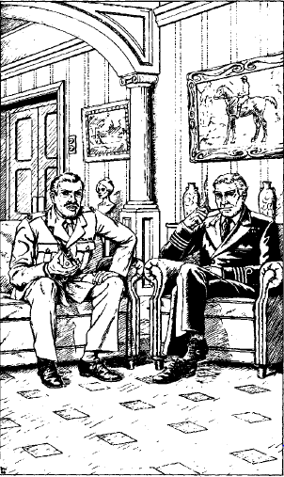

- Plais seddte, Thompson. Io imagine yu kamiete un explication, iey is.

Alistair nuk.

- Reikiete yu gairn France ? Sprohg Dunbar abrupt-ye.
- Pardon ? Iey Alistair.
- Sinte me vos explie, nabahsit is. Ste oin iom presten quoy hant skap' Deutschland. Paurskmos leuds samt sem recen' gnohsa os quo wakyet ter. Tehrbmos enplace un netwehrg kay parkwehre spionage, sabotage, hehlpe ad organise id Resistance ed antsalgihes bardachens.
- Quos ste yu, militar intelligence ? Sprohg Alistair.
- Ne druve-ye, antwohrd is Major. Smos id Special Operations Executive, id SOE. Kamiete yu joine nos ? Eiskwiemos ke yu wehrcte con iam franceois potnika yu habte brighen con vos.

Staunend, Alistair tohrb uno moment pre jawabe. Dind, is mynder-ye salutit mustahkam :

- Swamen, esiem honoret ob ses member ios SOE !

